Alex will create a form builder and mocha tests for client side
The way UI particle will work is relaying changes to server and be a websocket

Work Assignments
Alex: Form Builder
Ryan: Working Client Manager implementation in Rust
Dan: Bidirectional stream... rooms, finish simple message api
Nat: Console App for reading app manifest info

Console App
Add / Remove Packages
List Human Readable App Name + Signature

Web sockets and Particles
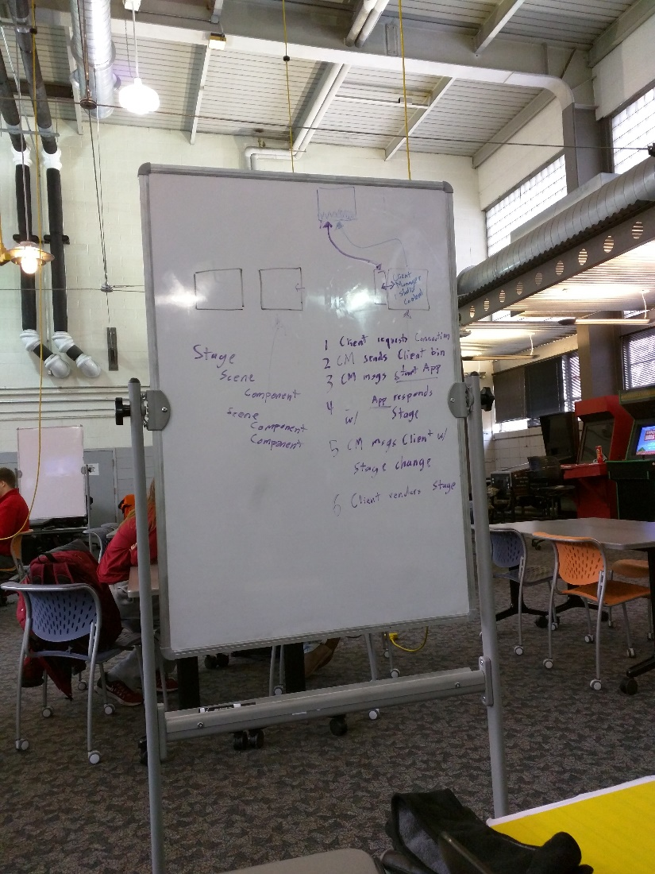
Each web page(s) is an app.
Apps have UI, probably.
For now, client manager only stores the current stage

UI setup
Stage
Scene
Component

New or Reconnecting UI Client
- Client Requests connection
- Connection Manager sends client javascript and static assets (“binary”)
- Connection Manager identifies client, if new then messages START app else resumes LAST app run by client
- app responds with UI stage
- Connection Manager messages client with stage change
- Client renders stage

Types of Particles
Certain types of particles will have a message type. Some are binary, some are analog
- Switch Type Particle
- Dial

Form builder
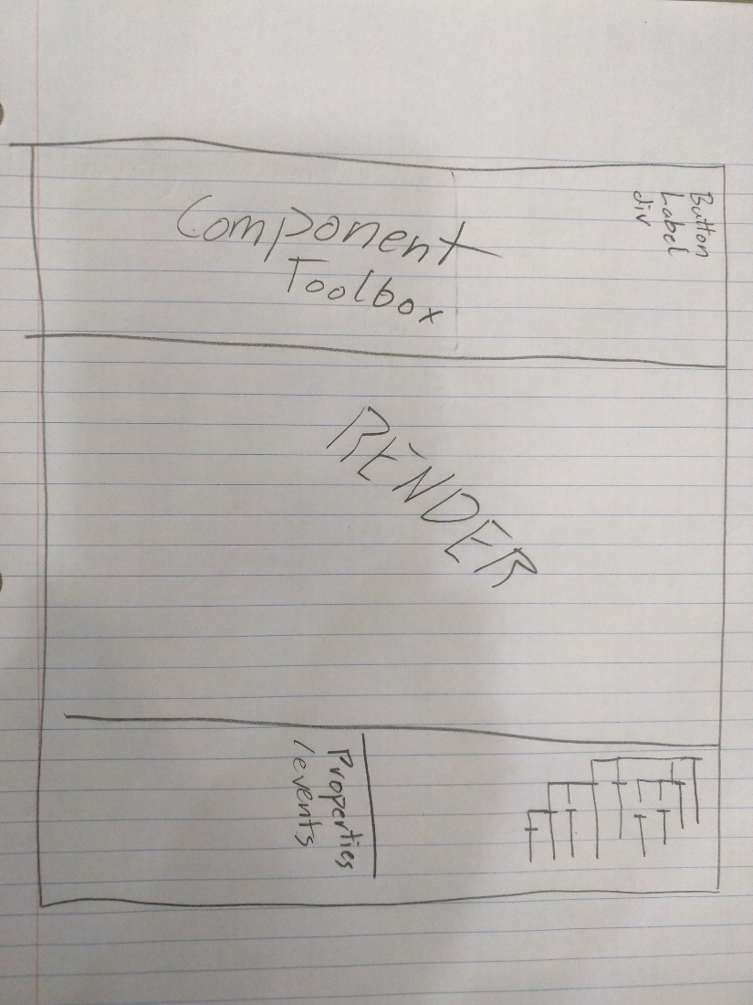

Store Info

Package
Manifest : TOML
Name
App Signiture
List Actions Supported (interface)
Permissions Needed
Resources
Binary
Icon

Action Libs
Action Lib Manifest
Action A...
Action C...

Action Helper Lib
Action: Implimentation URI
: Local URI

Structure of App
Apps
App List: TOML
<App Sig>
package
<App Sig>
package

Types of Actions
UI Action
Open From start
Open specific Scene

